

**High Level Design for**

**<Name> API**



**Version: 1.0**

**Author: Suraj Desai**

**Date: 31-December-2019**

Version: 1.0

Date: 31/12/2019

Author: Suraj Desai

Table of Contents

Revision Log 2

Purpose of this Document 2

System Overview 2

Brief overview of the System 2

Use-case Model 3

Functional Flow 3

Login API 3

Claim API 4

Dependencies 5

Open Questions 5

Appendix Section 5

# Revision Log

|  |  |  |  |
| --- | --- | --- | --- |
| **Date** | **Author** | **Version** | **Changes** |
| 31-December-2019 | Suraj Desai | 1.0 | Initial Draft |
|  |  |  |  |
|  |  |  |  |

# Purpose of this Document

This document provides a high-level overview and design of the <Name> API. The intended audience for this document is API Designers, API developers, API Proxy Developers, API Product Owner and Testers.

# System Overview

## Brief overview of the System

This documentation covers detailed design for all child use cases specific to Michelin Motor Sports API. This API will enable the Motor Sports team to file a Claim using the RSA mobile application. The user needs to login into the application before submitting any Claim. The current functionality is only restricted to summitting a claim information. The system currently does not support any functionality to view the status or modify the claim in any manner.

The API will be managed and proxied on the API management platform which will provide various gateway related policies to be applied to the API.

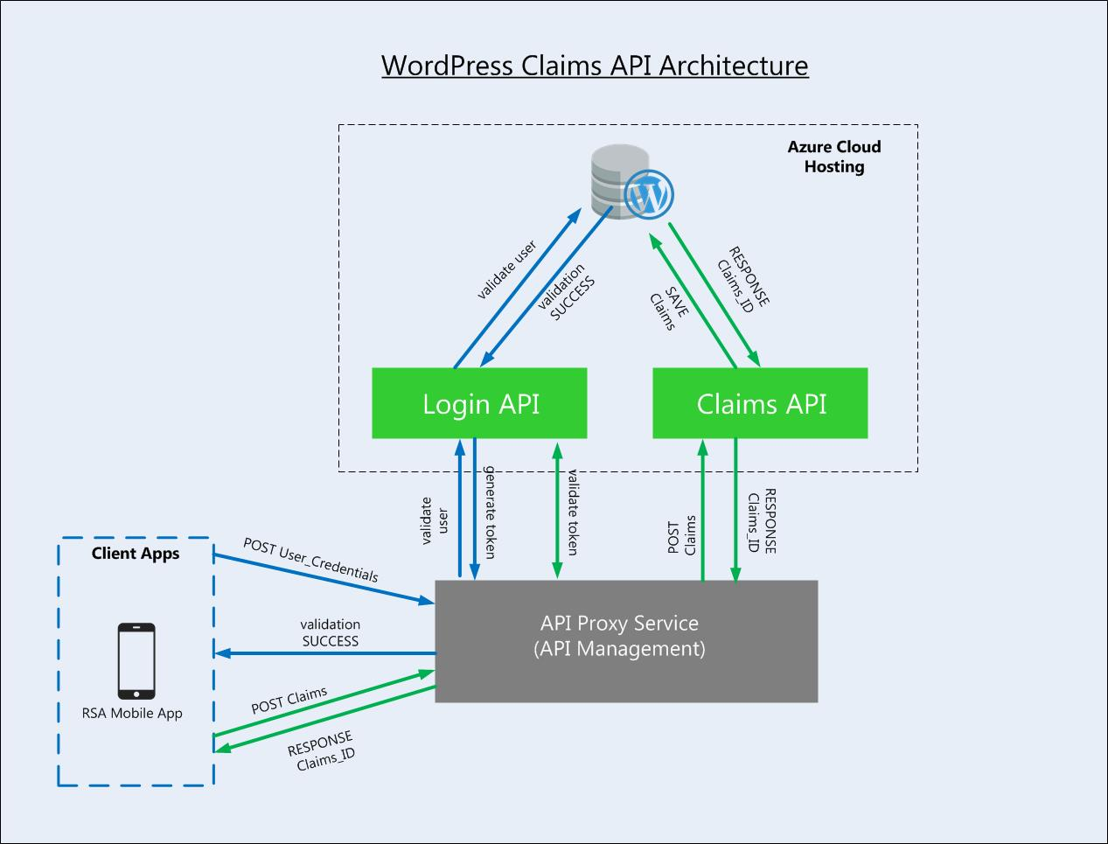

Diagram: System Overview

## Use-case Model

Use-case Model depicting interaction flows and interfaces between systems:



The above Use-case diagram essentially is an abstraction of following child use cases that leverage Claim functionality:

UC01: The Motor Sport team representative logs into the RSA application using a username and password.

UC02: The Motor Sport team submits a Claim related to Michelin Tire via the RSA App to the system.

# 

# Functional Flow

## Login API

#### Description

On RSA Mobile application, the motor sports team user needs to log to submit a tyre claim. The Motor Sport team representative logs into the RSA application using a username and password. An access token with a predefined expiry time is issued to the RSA application for the user if the login is successful. The RSA application needs to include this access token when a claim is submitted.

#### Input/output

Please refer to the open API specification link (link to open api).

#### Process Logic



## Claim API

#### Description

A logged-in Motor Sports team member submits a tyre claim using the RSA mobile application to the Claim API.

#### Inputs/Outputs

Please refer to the open API specification link (**link to open api**).

#### Process Logic



# Assumptions

# Dependencies

# Open Questions

# Appendix Section